Energy - Task 1. - Changes, changes, changes

Using electrical energy at home.

Electric current can transport energy to our homes. In this task you will look at the different ways we use this energy and how electrical energy is changed into many other forms of energy at home. In the diagram below some electrical appliances that we use to carry out the energy changes are shown. The exact place where the energy change occurs is shown in a circle beside each complete device. For example, the element in the radiator is drawn in the circle.

Look at the diagram and then answer the questions given below.

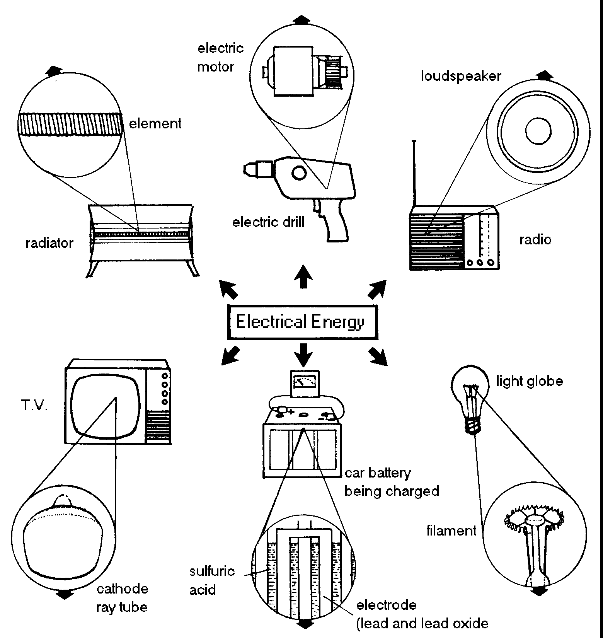

1. What do we use each of these appliances for?
a) radiator
b) TV
c) car battery
d) loudspeaker
e) light globe
f) electric motor

2. Give the name of an appliance that is used by us to turn electrical energy into:
a) sound energy
b) heat energy
c) kinetic energy

3. Each devise shown in the diagram changes electrical energy into other types of energy. In the boxes, write these types of energy.

4. Sometimes several types of energy come from one device. However, one type of energy comes from all the devices, whether it is needed or not! What type of energy is this?

5. What energy changes occur in:
a) a torch
b) gas oven
c ) solar water heating panels ?

6. For each of the six devices in the diagram, if possible, write down a way of doing a similar job without using electricity. For example, instead of using a clothes dryer, the clothes could be hung outside and the wind and sun could be used.

radiator:

electric drill:

radio:

light globe:

charging a car battery:

T.V:.

7. Draw two more pieces of equipment, which transform electrical energy, in a similar way to those drawn on the previous page. For each, show the types of energy that result from the transformation of electrical energy and where the energy change occurs.

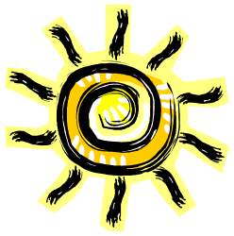
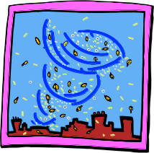
Energy - Task 2 - Using Renewable Energy

The Sun and the wind are both regarded as renewable sources of energy. In this activity you will chose one of these energy sources to make something happen.

1. Choose one of the following tasks

Task 1.
Your task is to get 10 mL of water as hot as possible in
30 minutes using only the Sun's energy.

OR

Task 2.
Your task is to build a wind-power machine which will
move 10 m in the shortest time.

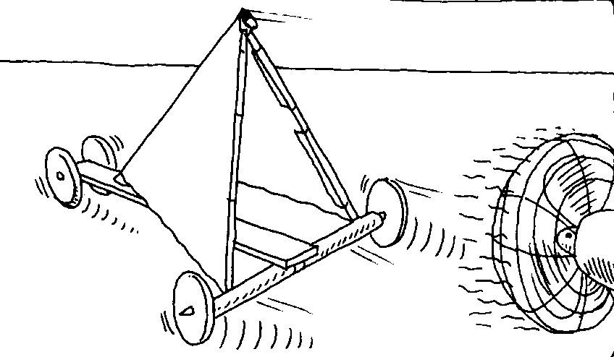
2. i) Plan your design
ii) Sketch your ideas
iii) Build your design

3. To test your design:
i) plan what experiment you will do.
ii) decide what you will measure, and how you will measure it.
iii) carry out your experiment and record your results

4. Make any modifications you think may improve your design. Retest your design

5. When you have finished designing and testing, prepare a report on your work.
This should include: - your design
- your results
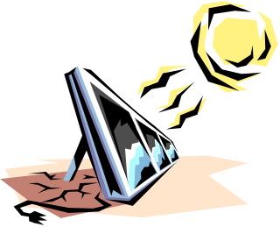
- suggestions of things you could improve.

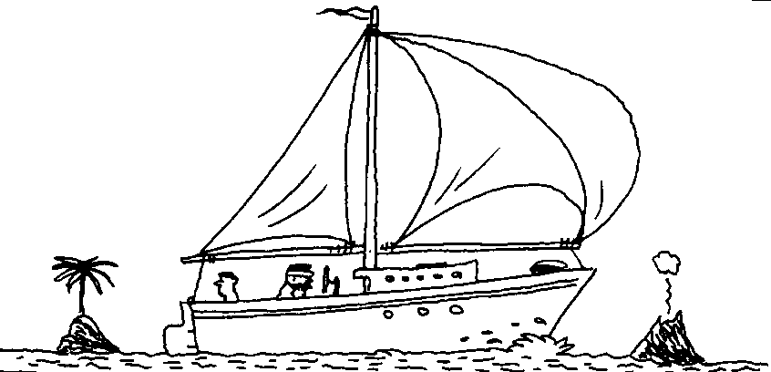

Energy and Change - Task 1. - Use of Energy at Home
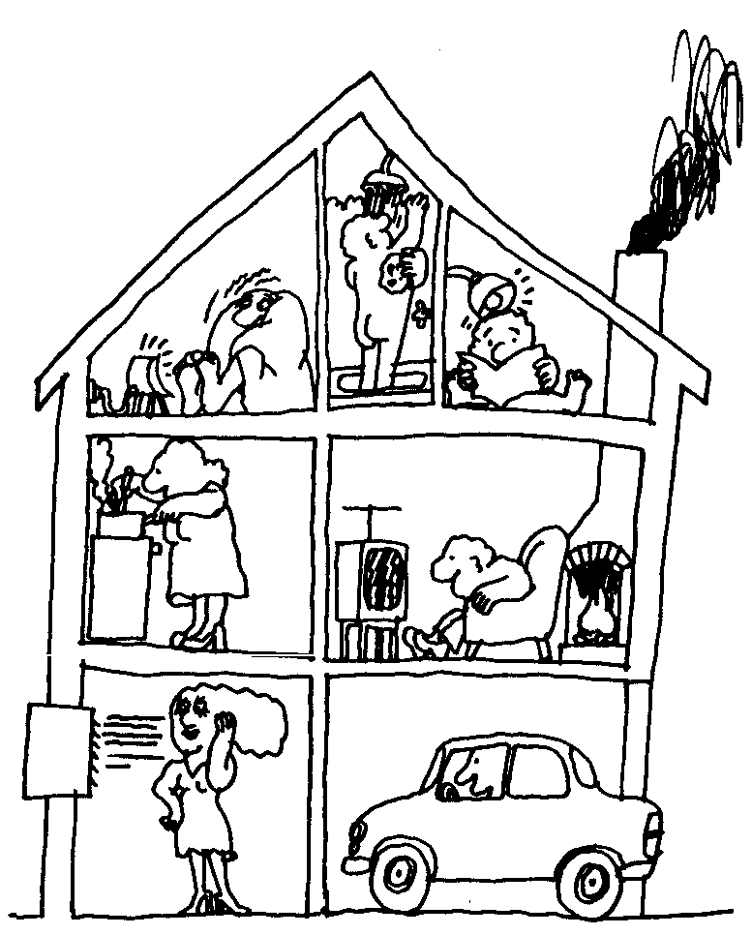

1. For one afternoon/evening, from the time you arrive home from school until you go to sleep, record the details of EIGHT different ways in which you and/or your family made use of energy in your home. Record your details in the table on the back of this page. One example has been completed for you.
(Ignore the use of energy by the human body.)

2. What was the major source of energy used in your home during this period of time?

3. What activity do you think used the largest amount of energy?

4. What activity do you think used the smallest amount of energy?

5. At what time did you/your family use the most energy?

6. At what time did you/your family use the least energy?

7. Describe several different ways in which the use of energy in your home would vary, from that recorded in your table,
a) in the morning.

b) in the middle of Winter.

8. Choose FOUR different activities described in your table and show the energy flow that occurred as you made use of the energy/energies.
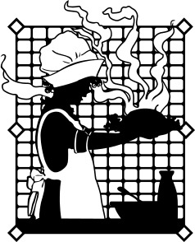
Also identify the appliances involved in this energy flow.
A simple example of an energy flow has been given below:

Activity: Using a filter pump in the fish pond

kinetic energy (moving parts of pump) kinetic energy (moving water)
electric filter pump
electrical energy + heat energy (in pump)
+ sound energy

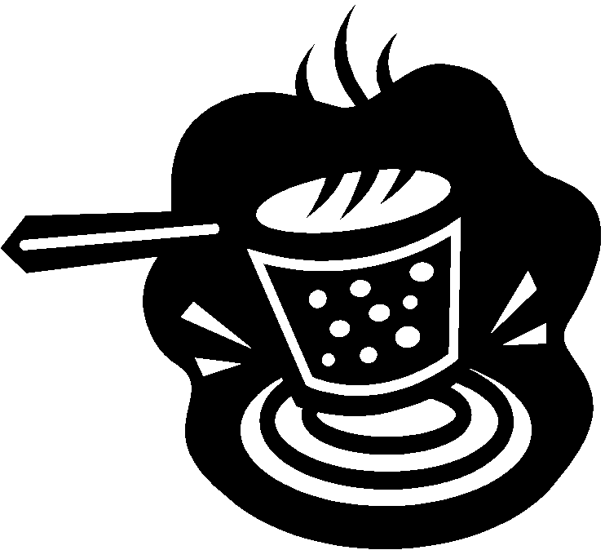
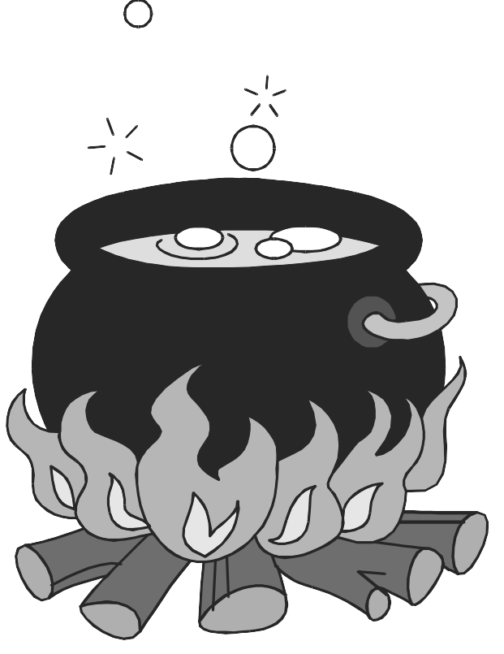
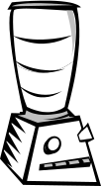
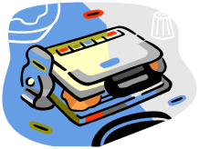
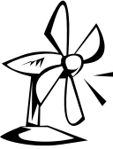
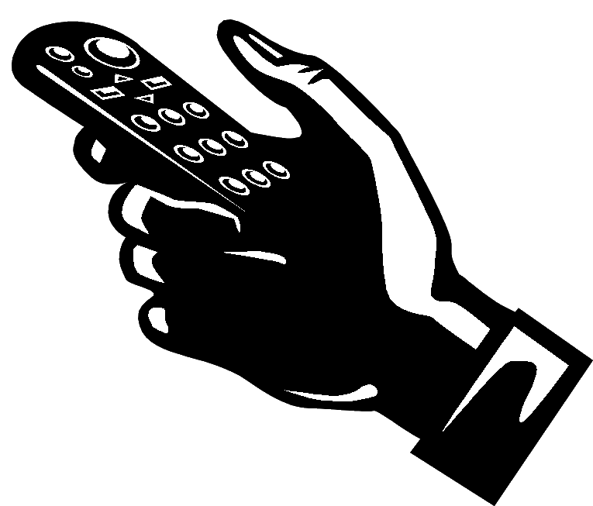
Use of energy at home

 | What was the reason for the energy use? | What was the source of energy, in the home? | What "appliance" received this energy? | What type or types of energy were finally given out by this appliance? | What time of day/night was the energy used? | How long was the energy used for?
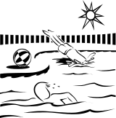 | to clean the pond water | electricity | filter pump | kinetic energy  sound energy  heat energy | all day and night | 24 hours a day
1.
2.
3.
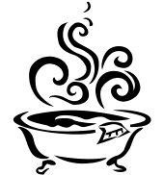
4.
5.
6.

7.
8. |  |  |  |  |  | 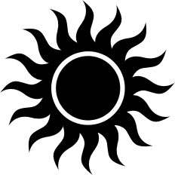
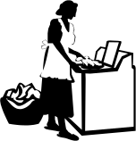
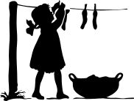

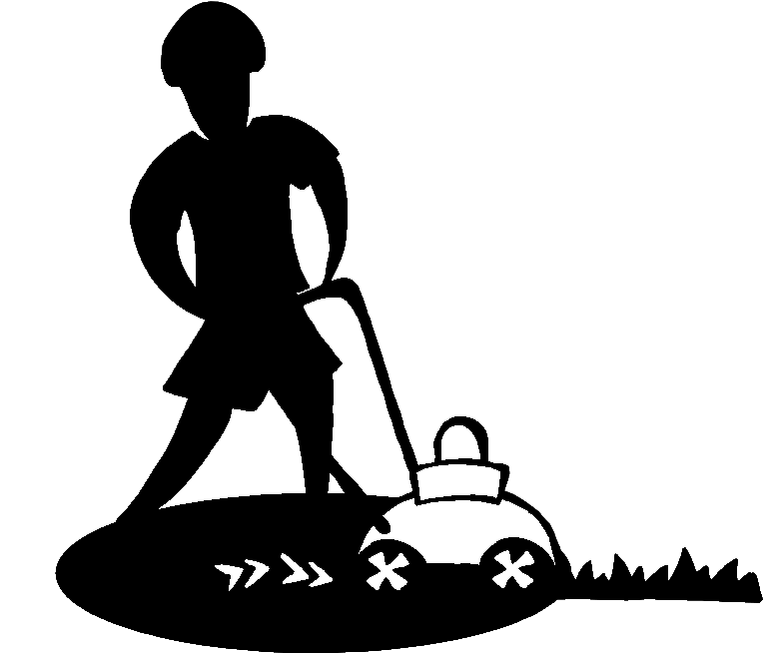

Task 2. - How much electrical energy do you use?

diary - check electricity meter regularly - plot graph and explain why increases occur

How to Read Your Electricity Meter
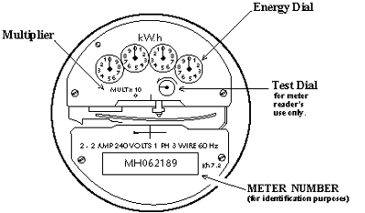
Most meters have four dials, like this one.
The hands on each dial turn in the opposite direction to the one beside it, either clockwise or counterclockwise.
Draw the exact position of the dial hands, record the meter reading in the boxes. If the dial hand is between two numbers, please record the lower number. If the dial hand is between 9 and 0, then 9 is the lower number. If the dial hand points directly to a number on one dial, be sure the dial to the right has passed zero. If not, record the next lowest number.
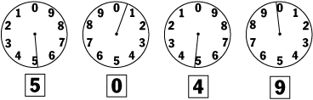

Western Power - http://www.westernpower.com.au/html/home/safety/your_electricity_meter/ - then click on “How to read your meter”

How To Read Your Meter
There are four types of meters: Dial Meter, Digital Meter, SmartPower electronic meter and Three phase electronic A1 tariff meter. Each of these meters is contained within a special meter box.

Dial Meter
The Dial Meter is read in the following way:
- Stand directly in front of the dial meter.
- Read each dial in turn going from right to left, writing down each figure, again from right to left, as you go.
- In the first illustration the reading is 2-7-0-3-8 (you would start by writing the 8 first i.e. right to left).
- When a dial points between two numbers write down the lower of the two numbers. For example, if it points between 0 and 1 write 0. Between 9 and 0 write 9.
- It is important to only read dials that are black.
Illustration 1
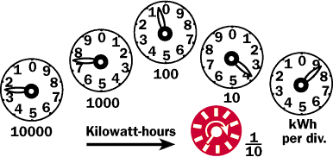
When a dial hand appears to be exactly on a number as on dial (D) in the second illustration, look to dial (C) to the right. If the hand on dial (C) has not passed zero, the number 5 has not actually been reached on dial (D) and the reading on that dial is the next lower number....4. In the second illustration the reading is 0-4-9-8-1.
Illustration 2
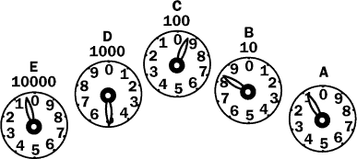

Digital Meter
Is similar to a car's odometer, where you simply read the numbers.

SmartPower Electronic Meter
The SmartPower meter continuously scrolls through the display sequence below. Each display lasts for 6 seconds and is identified by the number in the top left-hand corner of the meter.
We recommend you read your SmartPower meter on a regular basis so that you know in which periods you are using your electricity. This way you can make any necessary changes to your electricity usage patterns to help increase your SmartPower savings.
Displayed ID | Tariff Display Description
4 | Current Time
5 | Current Date
7 | Total kWhs
10 | On peak KWhs
20 | Off Peak KWhs
30 | Weekday shoulder kWhs
40 | Weekend shoulder kWhs

Three phase electronic A1 tariff meter
This meter continuously scrolls through the display sequence below, pausing on each of the displayed ID's for a period of six seconds.
Displayed ID | Tariff Display Description
4 | Current Time
5 | Current Date
7 | Total kWhs

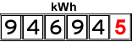

Energy - Task 2. Electrical energy at the flick of a switch
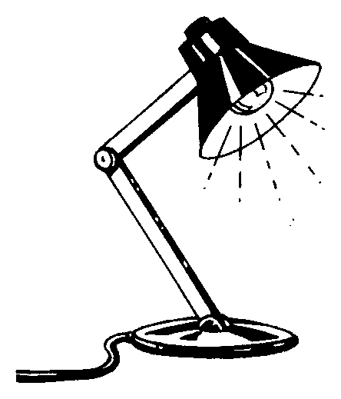
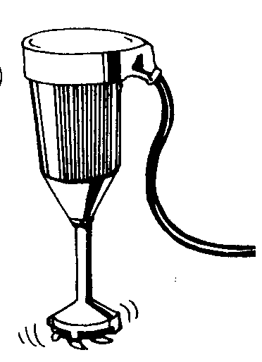

We use electrical energy to cook with, to keep us warm and cool, to travel and much more. Today, this electrical energy is available to us at the flick of a switch. If we flick one switch, we have light, if we flick another we get music or television. Flick another switch and our home becomes warmer or cooler. However, it hasn't always been that easy.

In this activity you will investigate the way in which the use of electrical energy in the home has changed over the years.
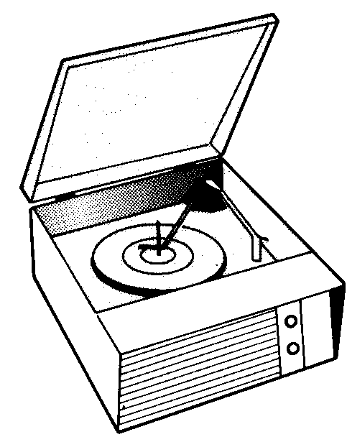
What to do

1. Write down a list of all the electrical appliances in your home.

2. By talking with older people, or referring to books or the Internet, find out which of these electrical appliances were used in homes 50 and 100 years ago.
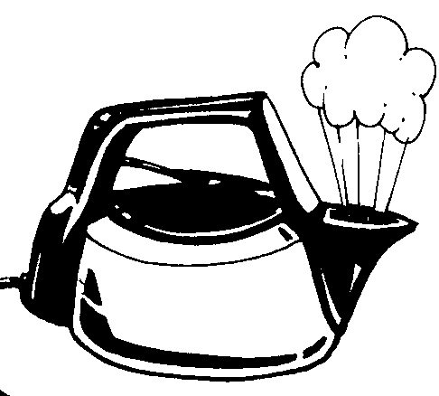

3. If the electrical appliance was not used, record what was used instead.

4. Determine the source of energy for this alternative appliance or device.

5. Compile your findings in a table similar to the one given below:

Electrical appliances in the home? | Did the appliance exist in the home 50 years ago? | What appliance/device was used instead? | What was the source of energy of this appliance/device? | Did the appliance exist in the home 100 years ago? | What appliance/device was used instead? | What was the source of energy of this appliance/device?
Lighting:
- globes
- fluorescent tubes
Oven
Hotplates
Vacuum cleaner
T.V.
etc

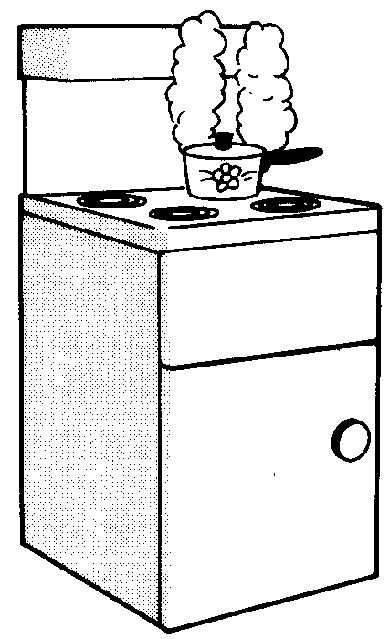
6. i) Comment on how the number of electrical appliances used in the home has changed over the past 100 years.

ii) Propose explanations for this change in use of electrical appliances over the last 100 years

7. Do we use more, less or the same amount of electrical energy now in the home compared to that used 50 years ago and 100 years ago?

8. What were the major sources of energy used in the home 50 years ago and 100 years ago?

9. i) When was electricity first made available for use in homes in Perth, W.A.?

ii) If you live in the country or overseas, when was electricity first made available for use in homes in your home town?

Energy - Task 3 - A Powerful Demand
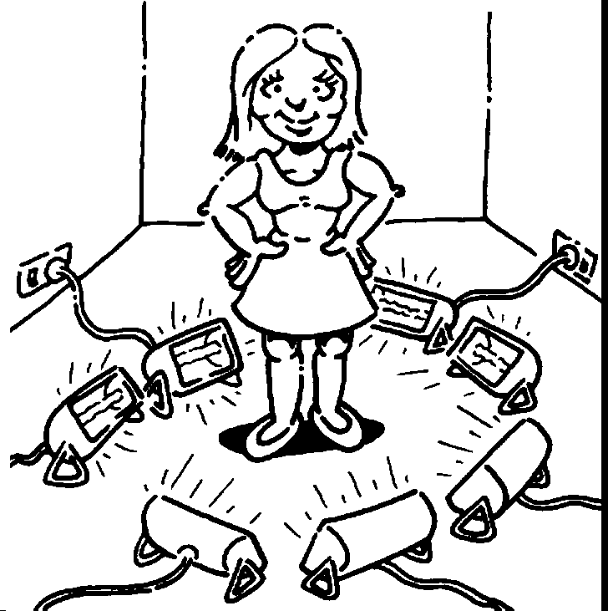
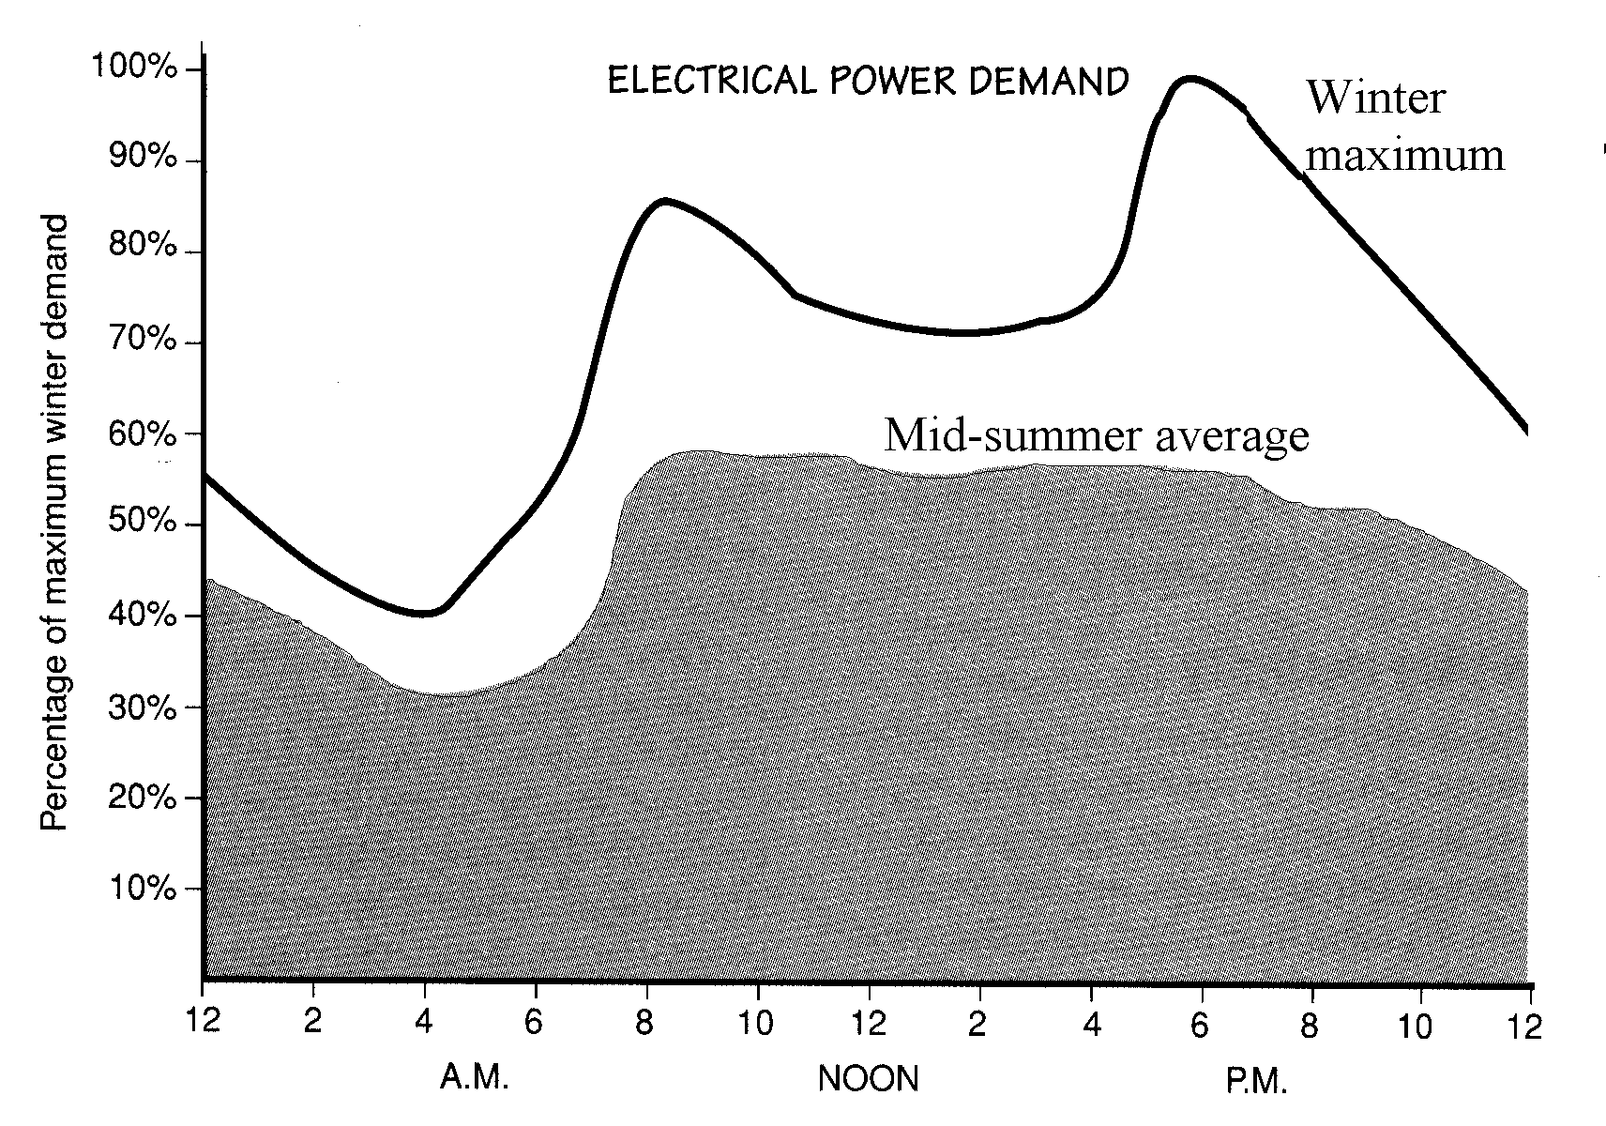

The graph above shows the typical demand for power in Australia on a weekday. Use the graph to answer the following questions.

1. At what time of the day does the peak demand occur in winter?

2. There is also a demand peak in the morning (in winter). When does this occur?

3. Explain the shape of the winter graph in terms of our use of electricity over 24 hours.

4. Why is the demand for electricity greater in winter than in summer?

5. If the peak demand on a winter's day is 10000 megawatts, what is the minimum demand on that day?

6. Even at 4 am we still use considerable electricity (about half the peak demand). How can you explain this?

7. Why is it that the summer graph has only one peak while the winter graph has two peaks?

8. In many states, the night rate electricity tariff is about one third of the normal rate. Suggest a reason for this.

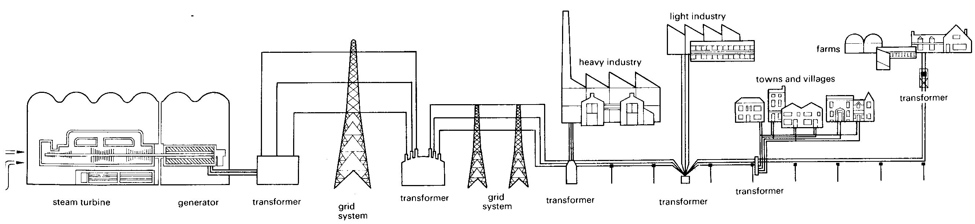

Task 5.
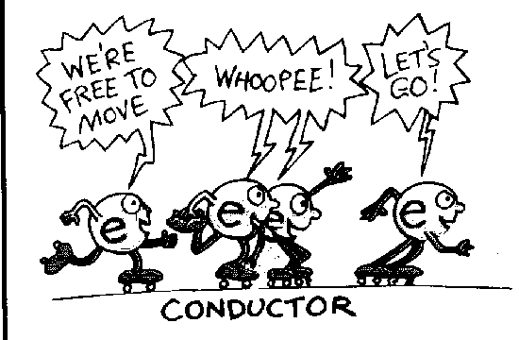

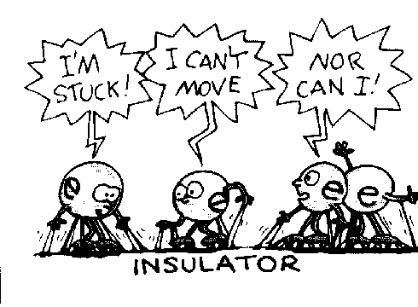

Getting Through

Do all substances conduct electricity?

1. Carry out an experiment to investigate this question.

2. Write up the experiment you used (hypothesis, method) and give the results you obtained.

3. Discuss your results.

4. Write a conclusion for your experiment.

5. When selecting materials from which to make electrical appliances or objects which may or do come in contact with electrical energy, the manufacturer needs to consider which substances do and do not conduct electricity.
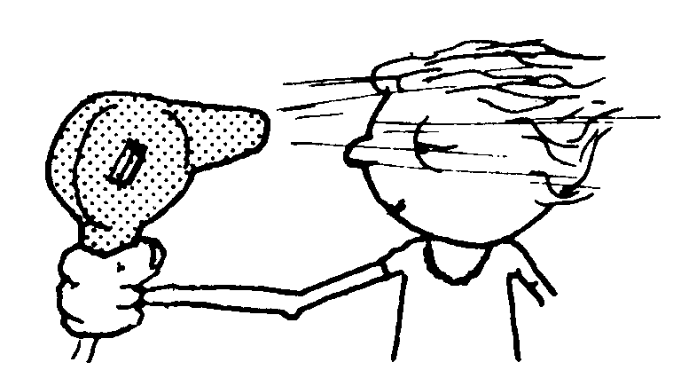

i) Which material is best for constructing light and power point switches? Explain your choice of material.

ii) List other objects and appliances, like power point switches, for which construction materials have been carefully selected. For each, explain why a particular material has been used.

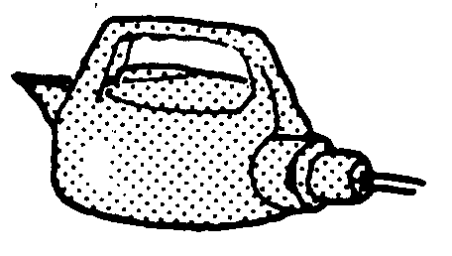
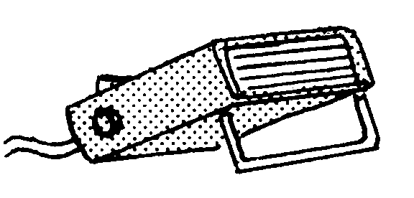
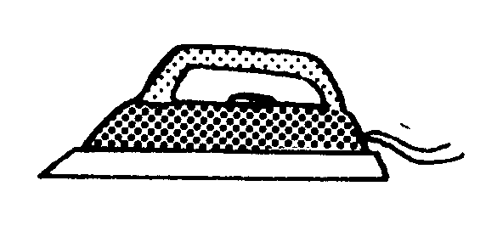

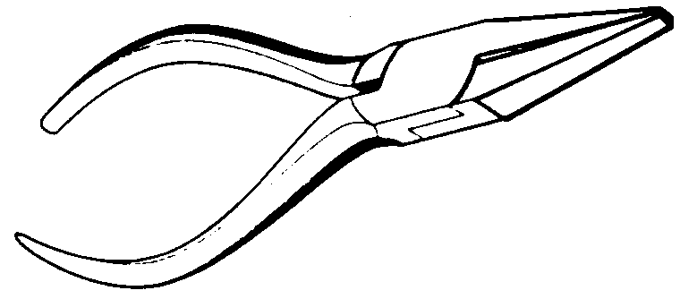

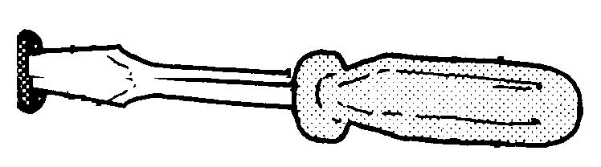

Energy - Task 6. - How does it work?
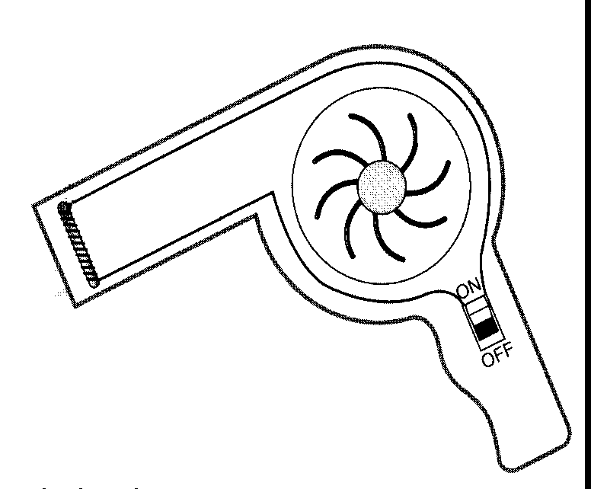
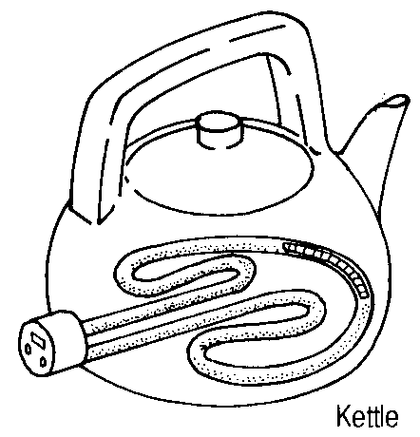

Electrical energy can be transformed into other forms of energy. In many devices used in the home, such as hair dryers, CD players, televisions, torches, dishwashers, electrical energy is transformed into heat, light, sound and kinetic energy. Most of these devices are powered by electrical energy generated at the power stations, but some devices are powered by electrical energy produced by a battery.
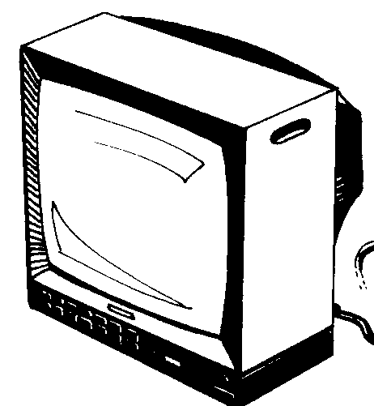

Part A. - Electrically-powered devices
1. List the devices in your home that are used to transform electrical energy into a different form of energy.

2. i) Sort your list into groups according to the type of energy they are designed to produce. That is, group the devices according to the type of useful or desired energy they produce.
For example, a hair dryer produces sound energy as well as heat energy, but it should only be listed in the heat- producing group.

Present your answer in a suitable table.

ii) In your table, include a column in which you can record whether the device is powered by electrical energy from a power station (mains electricity) or from a battery.
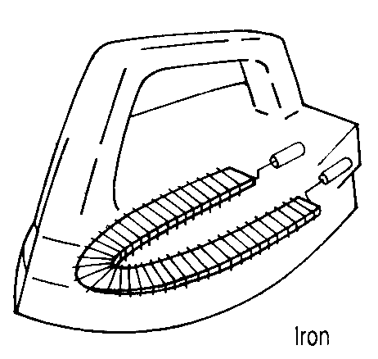

Part B - How does a simple electrically powered device work?

3. Your task is to explain how a simple device which converts electrical energy into another form of energy works.

i) Find an old electrically powered device.

ii) Examine your device. Draw a labelled diagram of it.

iii) Carefully take your device apart. As you dismantle it, list the steps in your procedure. Draw diagrams to illustrate this. (DO NOT attempt to rebuild or test your devise)

iv) Explain how you think your device works. Include simple diagrams.

v) Draw a circuit diagram for your device.

Extension

4. Look at the materials that have been used to make up your device. Try to explain why these materials have been used.

5. Make a model of your device, or another electrically powered device, to show how it works.
Discuss your plans with your teacher before proceeding.

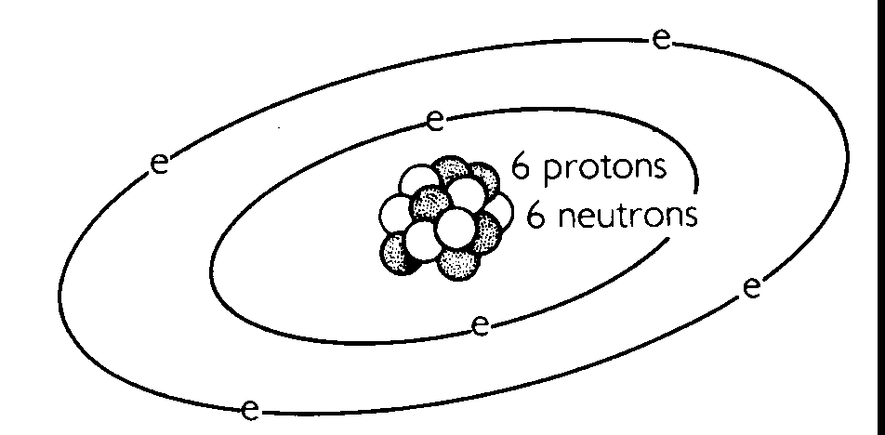

Energy - Task 7. - A Carbon Atom's Life Story

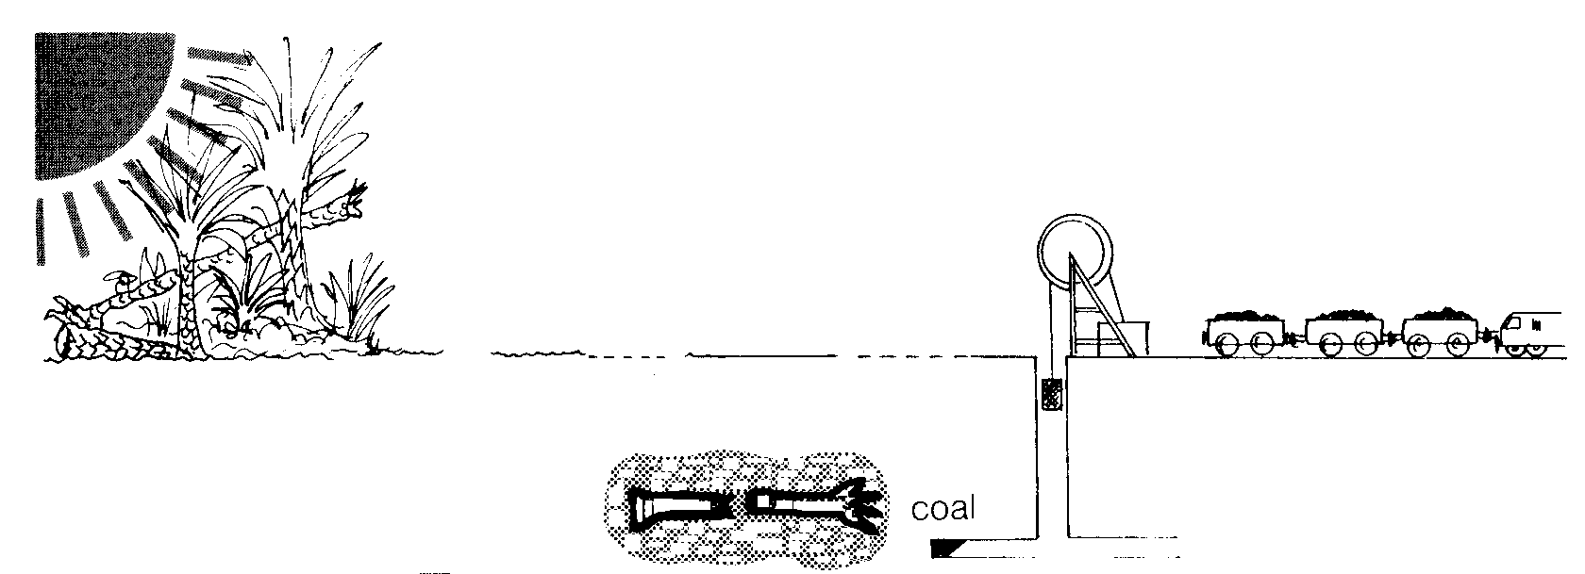
Coal is made out of carbon atoms.

Imagine you are a carbon atom in a piece of coal.

Write your life story beginning from the time when you were part of a carbon dioxide molecule in the air until you are finally burnt, as part of a piece of coal, in a power station.

As part of the story, refer to the energy transfers taking place as you change from one substance to another. Also mention the approximate time spans for each stage in your life.

You may present your life story as a written story, a cartoon, a power point presentation or as a talk to the class.

As a written story, it should be approximately ½ - 1 page in length.
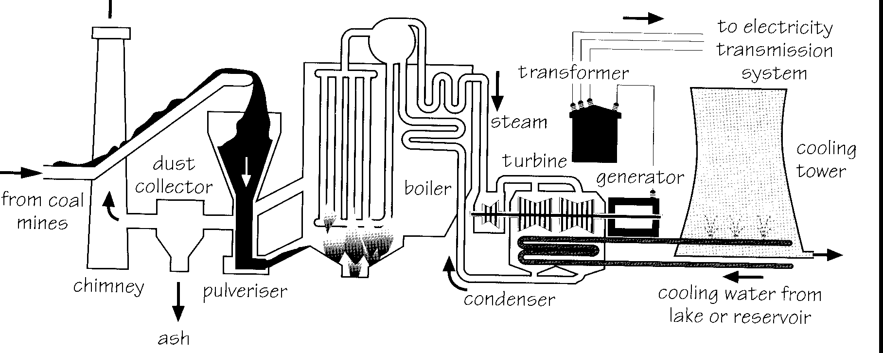

Extension

Continue your life story as a carbon atom to include other stages that might occur in your life on Earth.

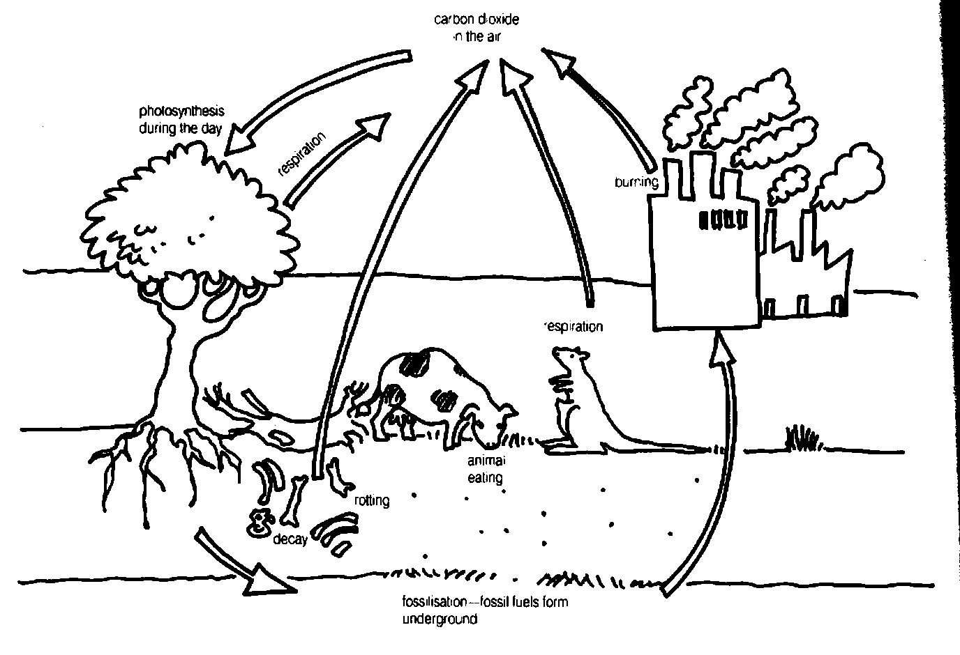

Energy - Task 8. - Turning Off
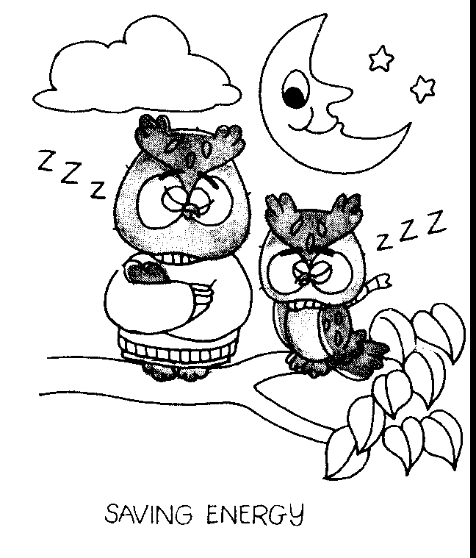

1. List all the possible reasons you can think of for why you should try to reduce the use of electrical energy in your home and at school.

2. Prepare a poster (A4 size) with an illustration or cartoon that will make ONE of these reasons clearer.

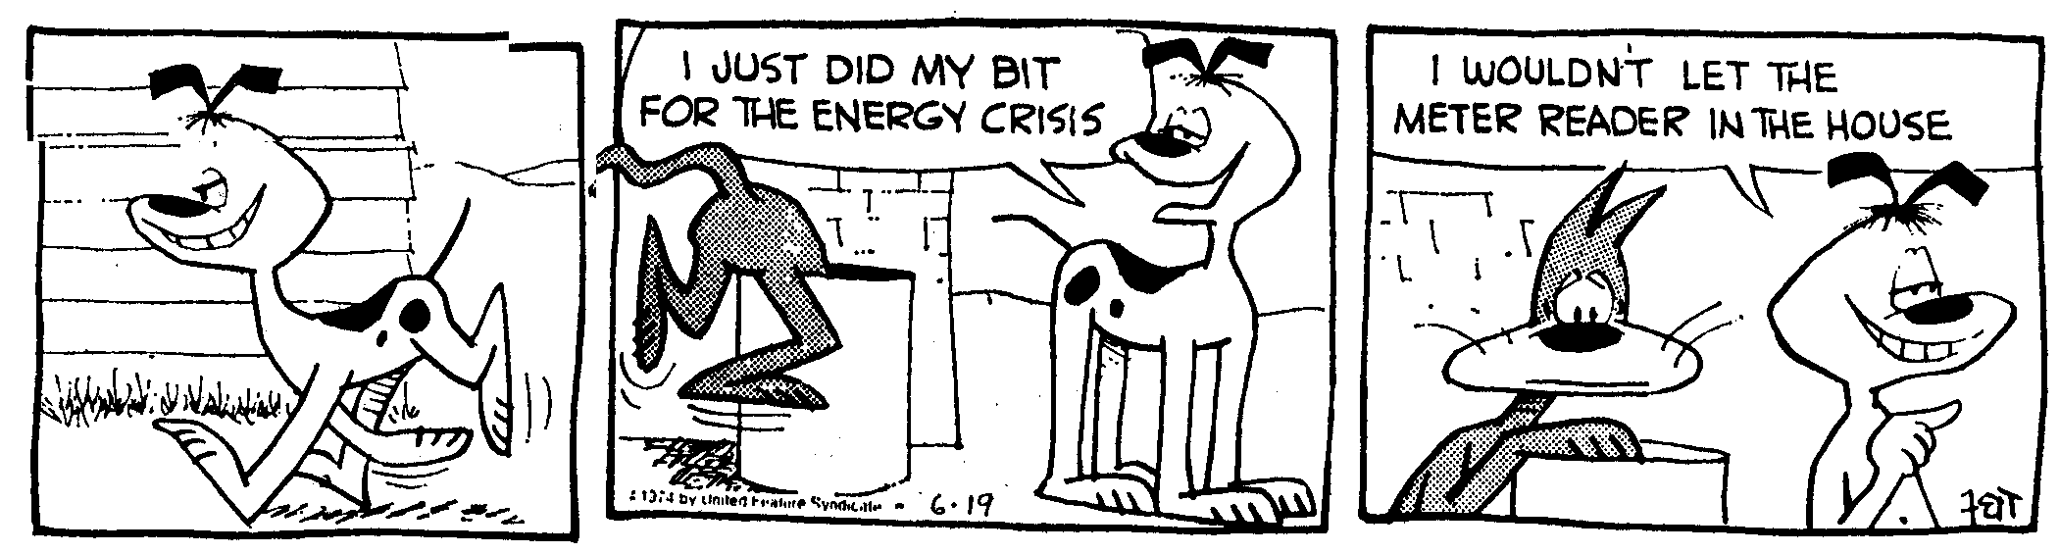

Energy - Task 9. - Turning Turbines
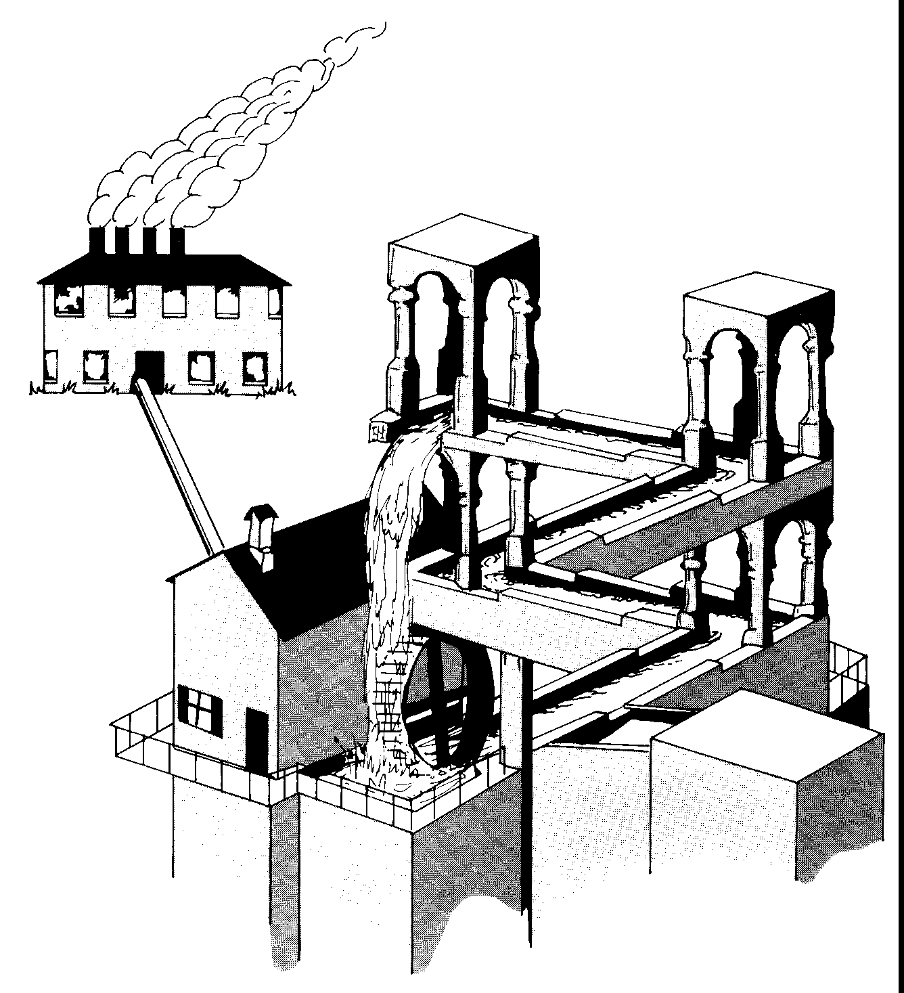

In Western Australia, coal and natural gas are used as the energy source for turning the turbines in a power station. Elsewhere in Australia and in the rest of the world, alternative energy sources are used. These
alternative energy sources include
wind
hydroelectric energy source
tides and waves
geothermal energy source
nuclear energy source

Part A -

1. Form a group of 2 or 3 students. Choose one of the alternative energy sources listed above.

2. Name two places where this energy source is used for producing electricity.

3. Find out how the energy source is used to turn the turbines in a power station.

4. List the advantages and disadvantages of using this energy source for producing electricity.

5. Prepare an attractive simple information sheet summarising your answers to questions 2, 3 and 4. This sheet should take no longer than 2 minutes to read and should be no longer than one page. Give your sheet to your teacher for photocopying.

6. Hand out your information sheet to the class. Allow the class time to read it, and then answer any questions they may have about the information contained on your sheet.

Part B (Complete this section by yourself)

If Perth's population continues to increase, it will be necessary for new power stations to be built. Which energy source do you think would be best for these new power stations? Give reasons for your decision.
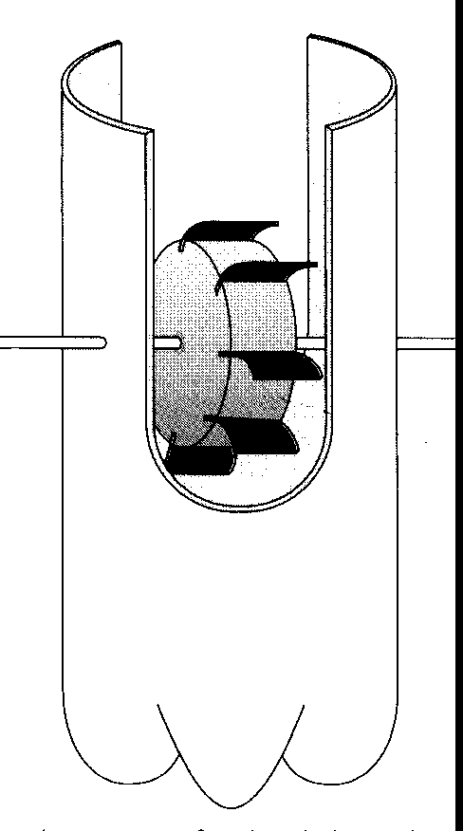
Your answer should be no longer than 300 words.

Part C

1. Form a group of 2 or 3 students. Choose one of the alternative energy sources listed at the beginning of this page.

2. Design and make a working model to demonstrate how your chosen energy source could be used to turn a turbine.

3. Draw a labelled diagram of your final model.

4. Comment on whether or not you think your design could be successfully used in a power station.

Energy - Task 10. - A Distant Attraction

Part A

Can the force from a magnet pass through different substances?

Plan and carry out an experiment to answer this question.

If you cannot decide on a suitable equipment set-up to use for this experiment, the following diagram may help.

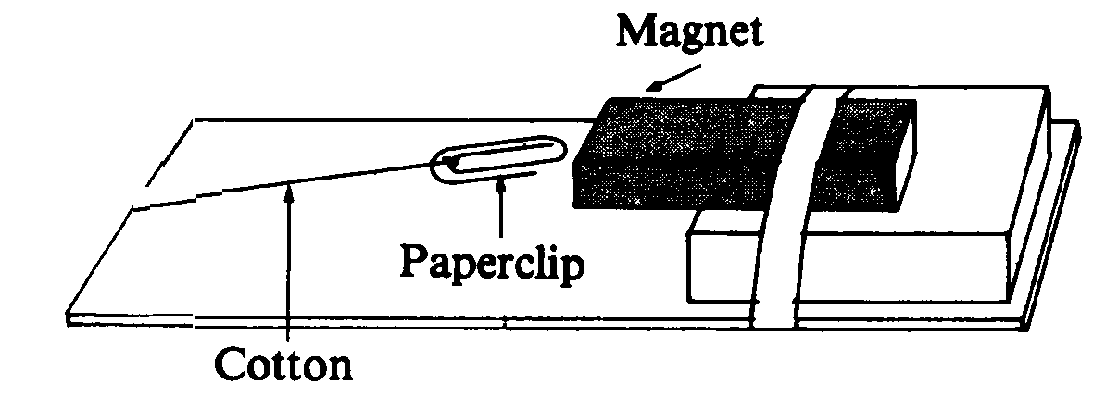

Part B - Useful magnets
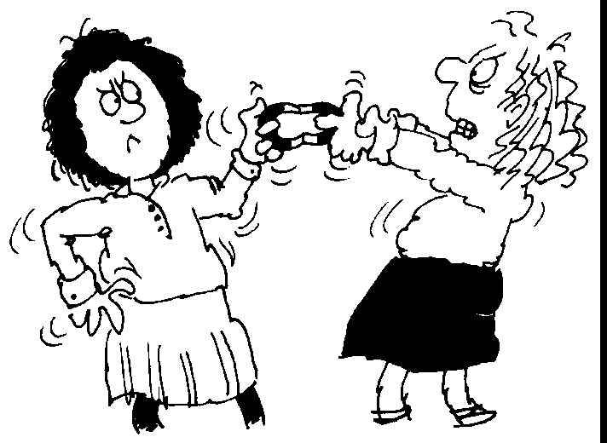

1. List ways in which we use magnets in society.

2. For each of the ways listed in 1), explain how the properties of the magnet relate to its use.

Extension

1. a) Find out what makes a magnet magnetic.

b) Magnetise a nail. Explain what has happened to the iron nail in the magnetising process.

c) Find ways of demagnetising your magnetised nail. Again, explain what happens in the demagnetising processes.

2. Design a game which makes use of the observation that a magnet force is a non-contact force.

Energy - Task 11. - Electromagnets

Many household appliances contain electromagnets.
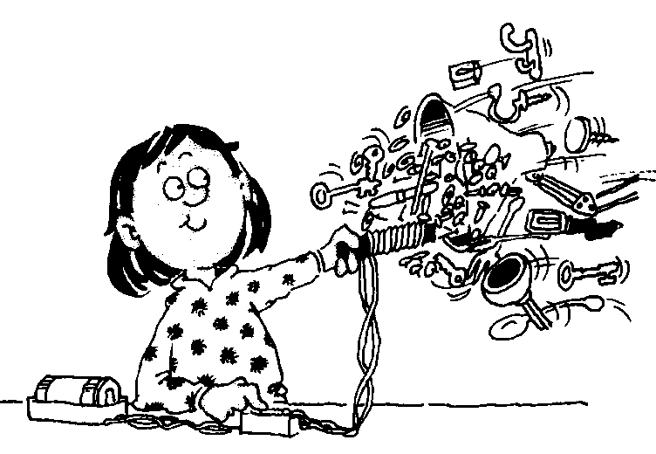

1. What is an electromagnet?

2. i) Make an electromagnet using wire, a nail and a power pack.

ii) Describe how you made your electromagnet.

3. i) Investigate the properties of your electromagnet.
ii) Record the method you used for this investigation.
iii) Record your results.
iv) Summarise the properties of your electromagnet.

4. i) Name some household appliances that contain an electromagnet.
ii) Choose one of these appliances and explain how the electromagnet works in the appliance.
iii) Attempt to draw an electric circuit for your chosen appliance.

Energy - Task 12. - The Energy Story of Electricity

Complete the diagram on the back of this page to summarise the forms and pathways of energy involved in the production and use in the home, of electrical energy:
i) name the different energy sources that are used in power stations to generate electricity
ii) identify the type of energy released by each of these sources
iii) identify the original sources and types of energy of the energy sources referred to in i)
iii) identify the types of energy involved in each step in the production of electricity in the power station
iv) label the type of energy produced by the generator
v) choose some electrical appliances used in your home which produce a range of energy types. Show these on your diagram together with the types of energy they produce.

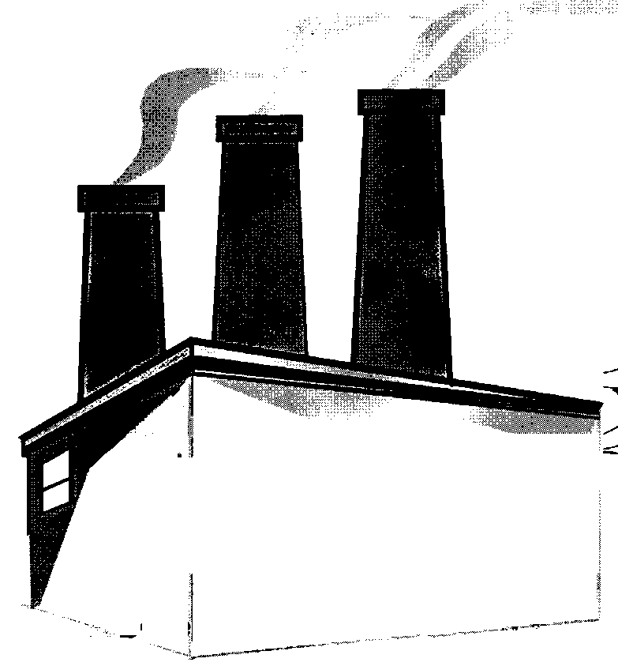
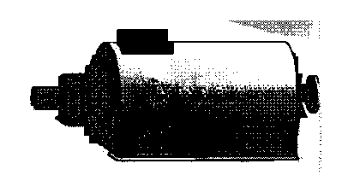
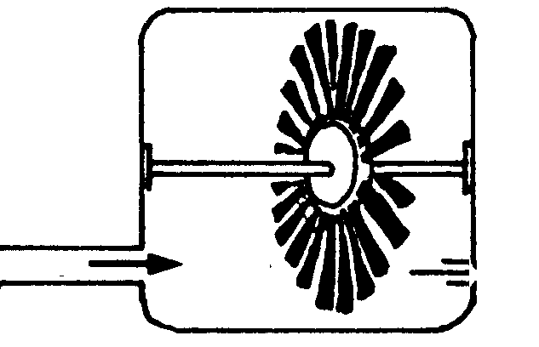
turbine
generator
ENERGY
original energy type of energy sources types of energy
sources original energy for power stations used in power
stations

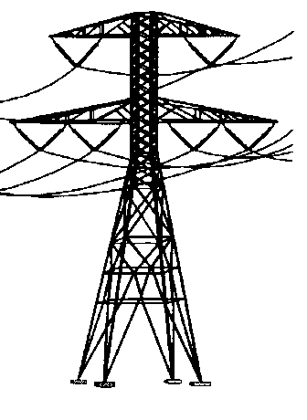

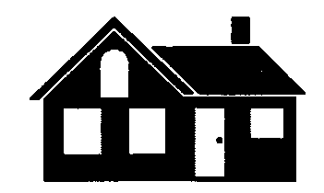

Energy - Task 13. - Energy Over Time
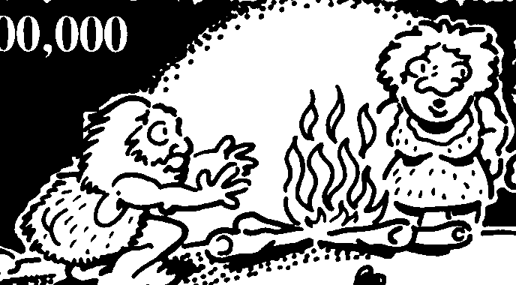

1. Examine the information shown on the "Energy Over Time" chart, then complete the following questions and activities.
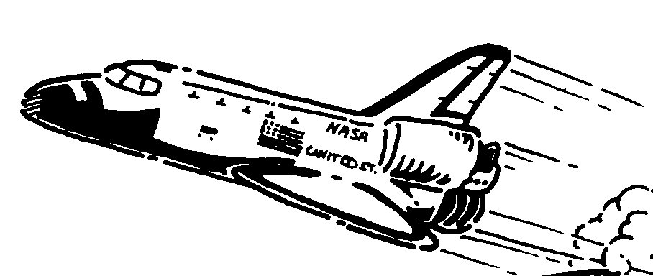

2. Complete the chart by adding any significant energy-related developments that
i) have occurred in the period 1981 to 2000.
ii) you predict may occur during the next 100 years.

3. Do you think that any significant energy-related developments have been left off the chart? Include these in the spaces at the side of the chart.

4. Developments in technology are illustrated from time to time on the chart. Which five milestones in technological development do you believe have led to big increases in consumption of energy? Explain your choices.

5. The graph below shows the energy consumed per person living at various times as a percentage of that consumed per modern person.

Amount of energy consumed per individual person in each age of human development
compared to a modern person
Energy per cent
of current total
100
90
80
70
60
50
40
30
20
10
0
Stone Late Stone Copper and Industrial Energy
Age Age Bronze Age Age Age

a) Determine the approximate dates (in years) for each age represented in the graph.
b) What trend does the graph show?
c) Record in a table, the types of energy, and the sources of energy, used in society for each of the ages.
c) During which ages did the two largest increases occur?
d) Explain why these might have occurred.

Extension

6. a) Develop a time line, from pre 500,000 BC to 2000 AD, which shows how different types of energy have been
used for transport up to the present time.
On your chart i) identify the types of energy used and the source of this energy
ii) name the types of transport that used this energy
iii) also attempt to indicate the proportion of each type of transport used at particular times throughout this time span.

b) Extend your timeline to include predicted forms energy and of transport which may be used during the twenty-first century.
Energy - Task 14. - The Sound of Silence
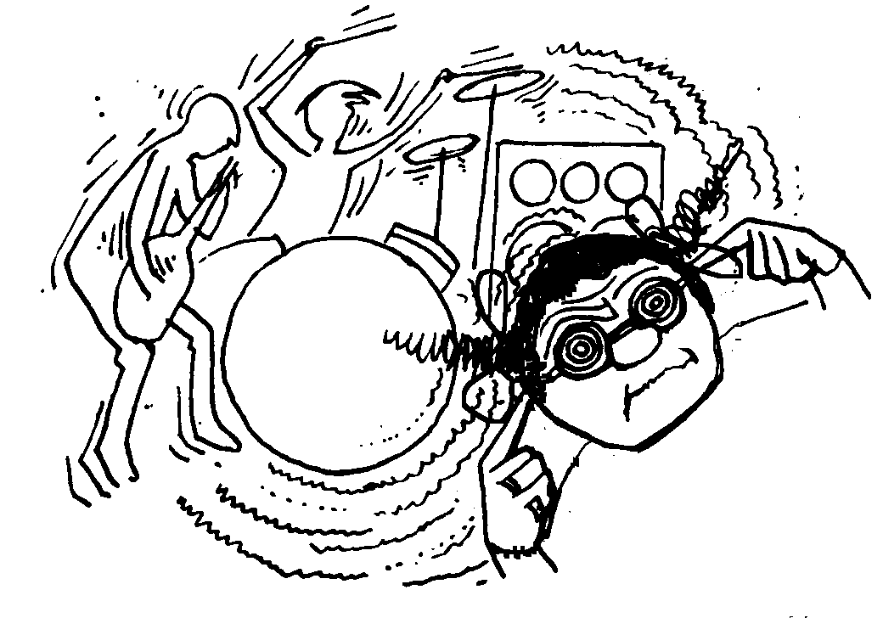

Your problem is to design a box that blocks out the noise from a source such as a small radio or a watch alarm.

1. Collect materials you think will absorb sound, such as newspaper, polystyrene foam, egg cartons and wood shavings, and a cardboard box.

2. Design and build your 'soundproof box'. Leave enough space for the radio, and don't forget to include a lid or door.

3. Work out a way of testing how well the insulation cuts down the noise.

4. Give your design a mark out of 10.

5. Write a report (with pictures) that describes your design, how well it did the job, how you measured the noise reduction, and any suggestions for improvement.

Energy - Task 15. - Sound, Sound and More Sound!

Choose one of the following questions or problems to investigate.
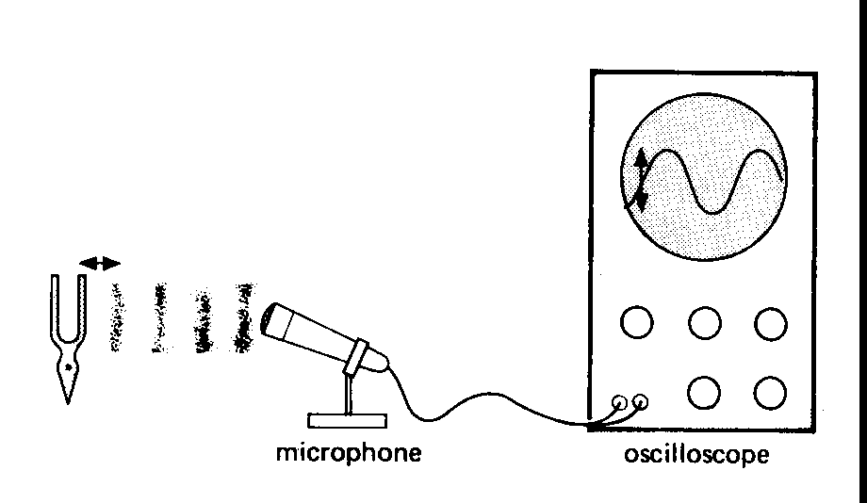
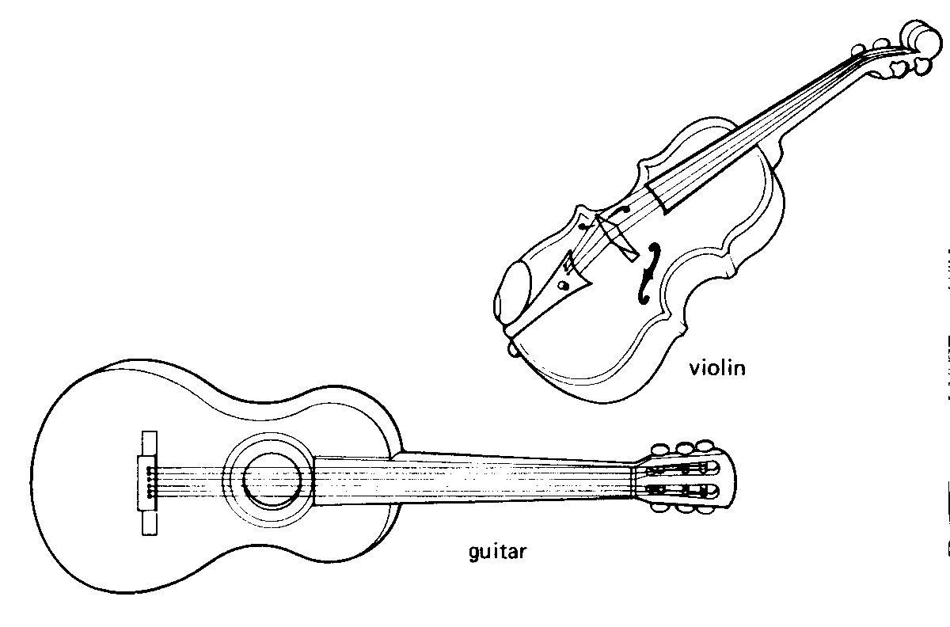
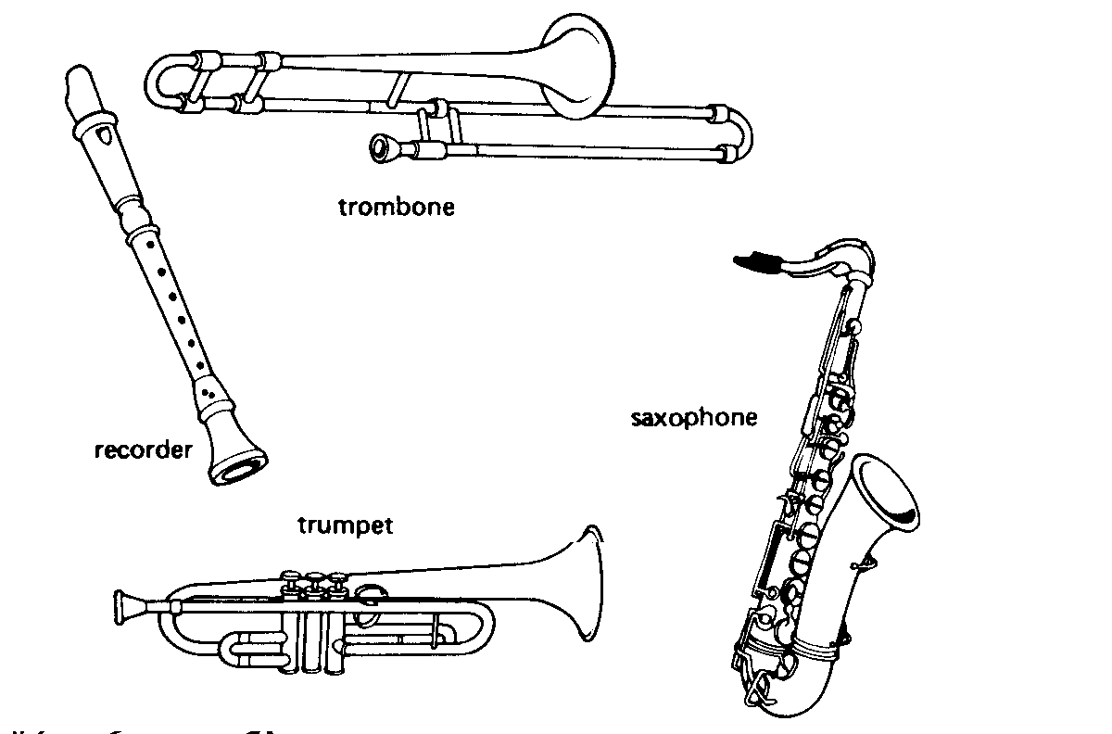
1. Investigate sound waves, using an oscilloscope.
2.How do string and wind musical instruments work?

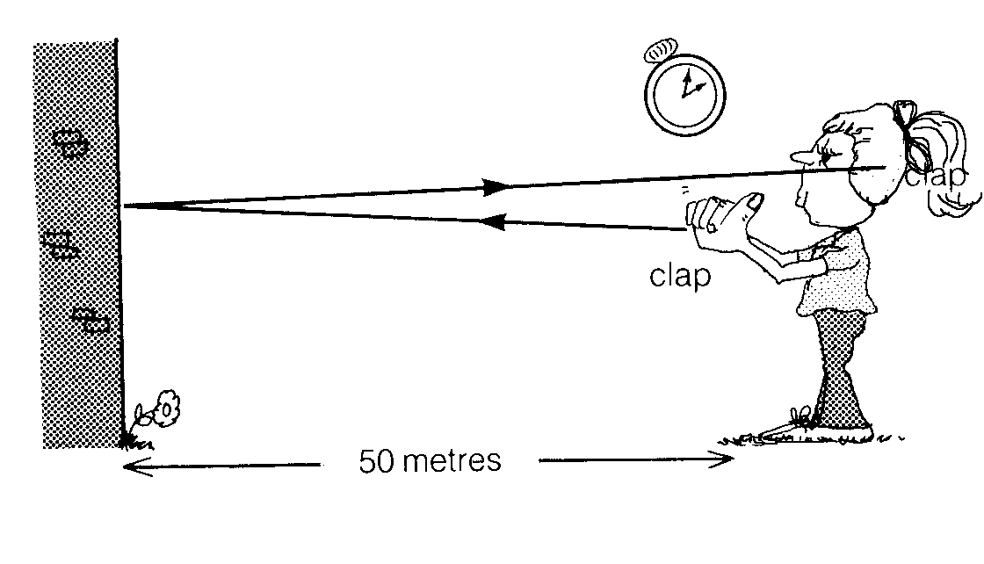
4.How fast does sound energy travel through air?

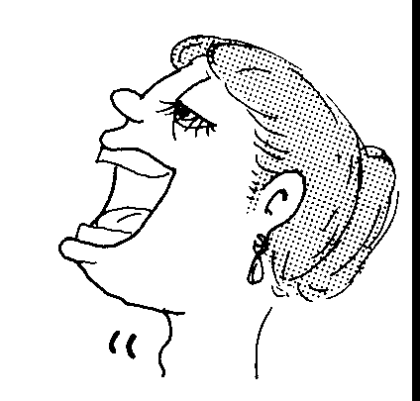
3.How do human's produce
sound energy with
their voice box?

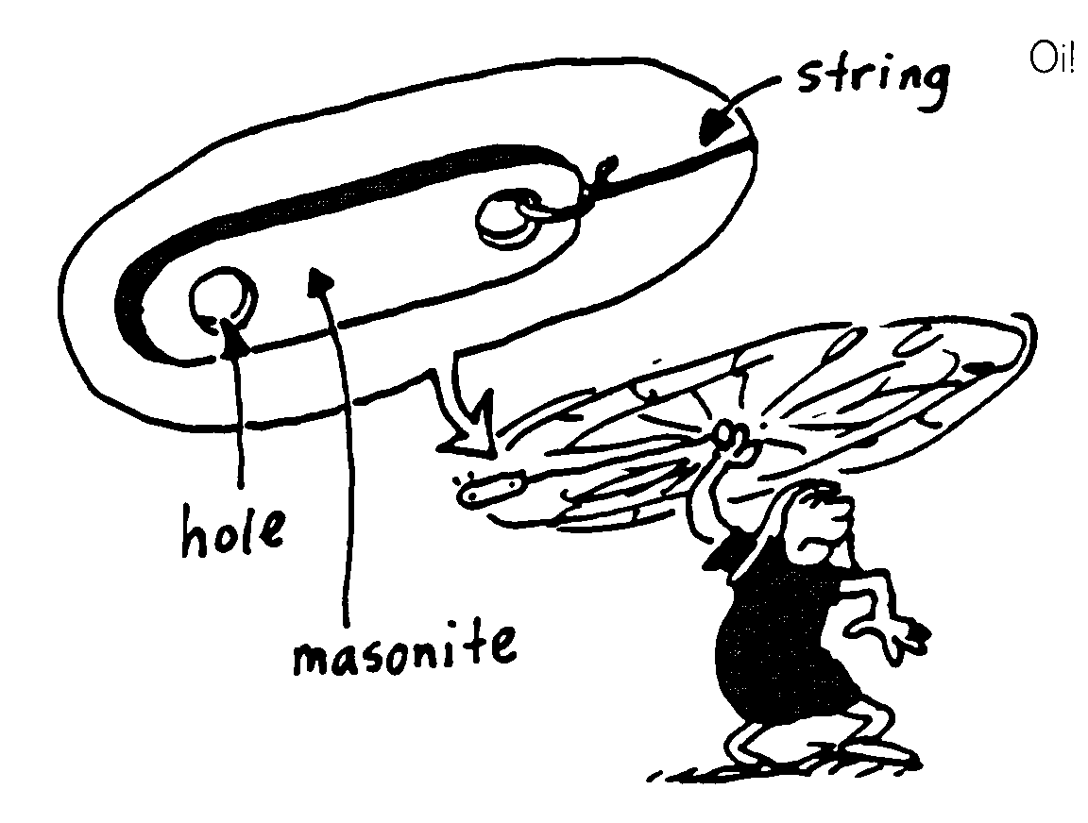
5. A bull roarer can be used to make sound.
Design and carry out experiments to find out
what factors affect the sound made by a bullroarer.

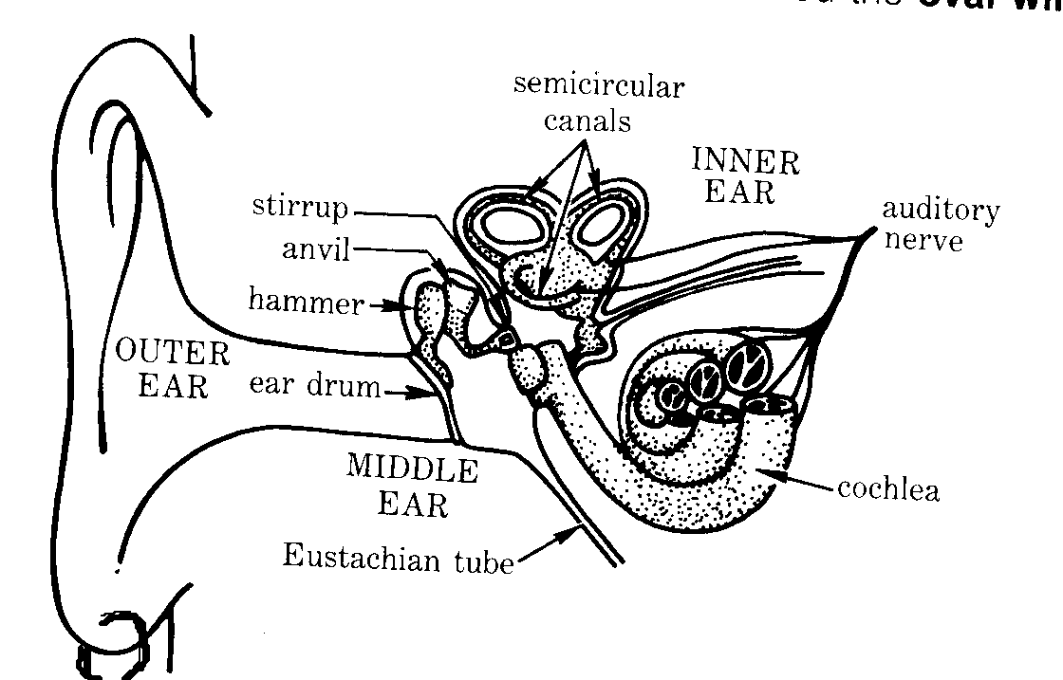
6.How does our ear
work?

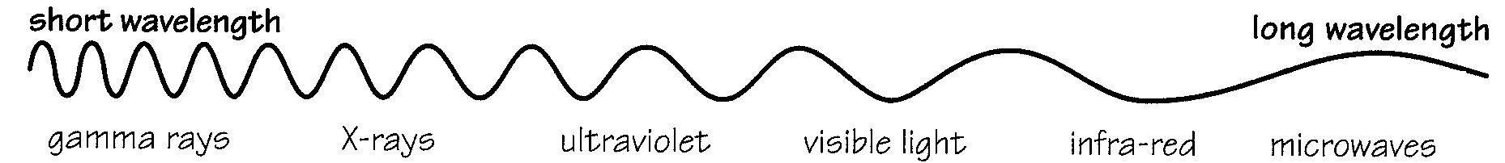
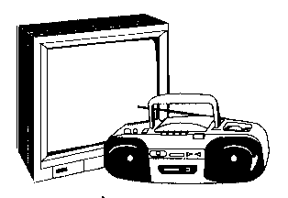
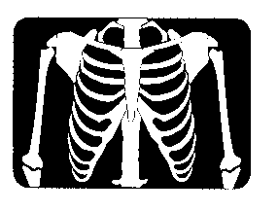
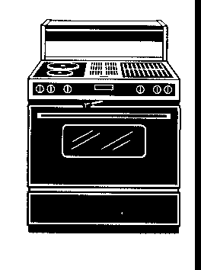

Energy - Task 16. - Use of Waves

The electromagnetic spectrum is made up of a family of waves. We make use of most of these types of electromagnetic waves (or rays).

For each of the following electromagnetic waves
radio waves
microwaves
infrared rays
ultraviolet rays
X-rays
gamma rays

a) list the range of wavelengths

b) give typical uses and names of the appliances or objects that emit the waves/rays

c) state the energy changes that these waves/rays can bring about when they come in contact with different substances.

d) describe the ways in which the waves/rays could be dangerous.

e) describe ways in which we can protect ourselves from the waves/rays

Extension

Describe how the waves/rays can be made, for example by appliances, on Earth.

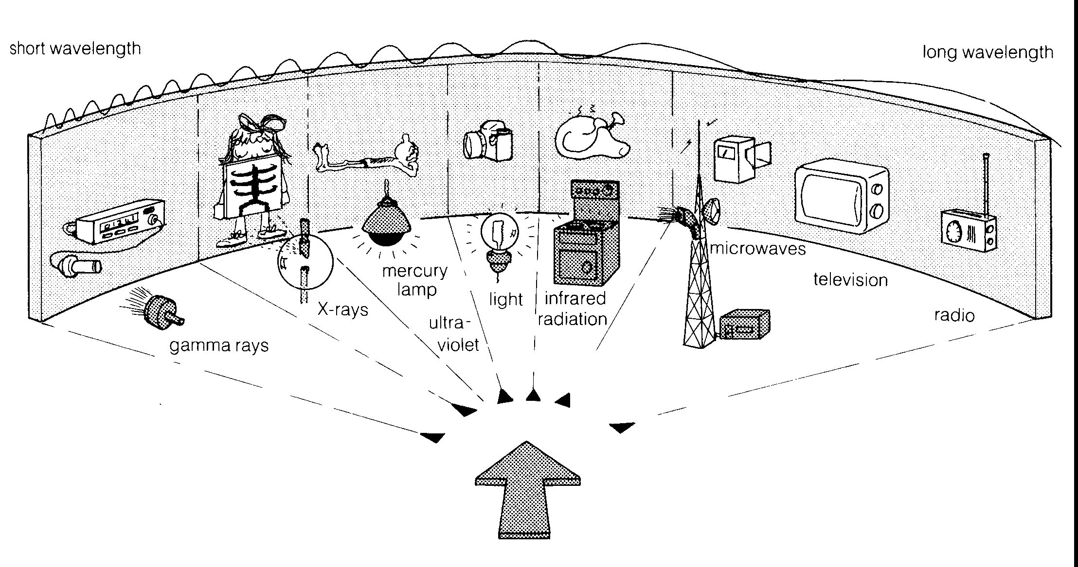

Energy - Task . - What is it made of?

Discuss materials that are transparent, translucent and opaque and make a general statement about each of these types of materials.

Discuss the uses made of these three types of material.

Display some objects made from transparent, translucent and opaque materials. For each object, explain why the light transmitting property of the material best suits the use of the object.
Energy - Task . - Straight Movement

Devise three different experiments which support the hypothesis that light travels in straight lines.

Carry out the experiments.

Give your results and conclusions.
Energy - Task . - Globes and Tubes

Many different types of electric light sources are available for use in the home.

1. List these different types of electric light sources

2. Explain how light is produced for each globe. Give the energy transfers involved in these processes.

3. How do we use each of these different types of light sources.

4. Discuss which globes are best to use for various purposes in the home.

Energy - Task . - Better lighting, better light?

The table below lists the inventions of light sources that have been made over the ages.

7000 BC Oil lamp of carved stone from Mesopotamia used to burn animal fat
1000 BC Candles made by dipping strands of cotton or flax into animal fat
1500 Mould-poured candles invented
1799 Gas lamp patented in France
1807 First street lighting provided by gas lamps in London
1836 First claim of electric light by Scottish schoolmaster, this claim is disputed
1850 Paraffin (used today in candles) made from coal
1860 British inventor Joseph Swan invented carbonised paper filament electric lamp
1879 Swan demonstrated longer life filament lamp
Edison demonstrated electric light
1885 Gas mantle invented that gave off incandescent light
1907 Tungsten filament (used in modern globes) introduced
1910 Neon light invented, which could be made in any shape
1934 The modern globe with a coiled filament introduced
1939 Fluorescent light (mercury vapour lamps) produced commercially, producing four times the light for the same electricity as an incandescent globe
1960 Light-emitting diodes (LEDs) and laser first used

i) What sources of light used in homes between 1000 BC and 1500?

ii) Explain how each invention changed the patterns of people's lives.

iii) Why do you think people over the ages have looked for better ways of lighting the night?

iv) For each type of lighting describe the energy source

Extension: Explain how each of the different types of lighting works. Include a diagram of each of the different types of lighting.
Reading 35: Electromagnetic radiation and the atmosphere

You already know that the sun radiates energy covering the whole of the electromagnetic spectrum. You know that some of this energy, such as X-rays, gamma rays and ultraviolet radiation have very harmful, even lethal effects on the human body. The atmosphere surrounding the Earth provides selective screening of the radiation from the sun. Various layers of the atmosphere absorb different portions of the electromagnetic spectrum. Gamma rays are absorbed in the upper portion of the atmosphere (the ionosphere). Their energy is used in ionising oxygen and nitrogen molecules. X-rays penetrate further into the atmosphere to within 80 km of the surface of the earth. They too provide energy for the ionisation of gases in the upper atmosphere.
Ultraviolet radiation is absorbed by a band of the atmosphere lying approximately 20 to 30 km above the surface of the earth. This band contains ozone (03) which absorbs all but a very small portion of the ultraviolet radiation incident from the sun. It is thought by some scientists that supersonic transport aircraft flying in this region of the atmosphere may cause an imbalance of the oxygen-ozone proportions allowing ultraviolet radiation to reach the ground. This could prove to be very dangerous to human life.
Light reaches the surface of the earth. It is not unaffected by the atmosphere as the gas molecules cause it to be scattered. Blue light tends to be scattered more than red light, thus causing the sky to appear blue. You will have noticed that at sunset the western sky often appears to change colour from blue, through blue-green, to yellow, orange and even red. This occurs because the light at the red end of the spectrum is able to penetrate further through the atmosphere than the blue light.
Dust, smoke and other pollutants also cause scattering of light. Sometimes smoke from bush fires in Australia crosses the Tasman Sea, causing brilliant red sunsets in New Zealand. Water in the atmosphere also affects light travelling through it. Sunlight can be refracted by water droplets to form rainbows. At ground-level you see semicircular rainbows. Pilots of aircraft observe fully circular rainbows. On the ground clouds may appear black because they reflect and scatter light incident upon them. Above the same clouds a pilot will see brilliant white tops where light is reflected back into the atmosphere.
Clouds control the amount of light and infrared radiation reaching the earth. Clouds can prevent infrared radiation reaching the earth and also prevent infrared radiation re-emitted by the earth from travelling out into space. In cold areas cloud cover is sometimes sufficient to trap the infrared radiation from the earth, preventing frosts from occurring and thus helping to stabilise ground temperatures and preventing the extremes that might otherwise occur.
Light also undergoes refraction in the atmosphere. As the sun sets you will notice that its shape appears to change from circular to being nearly elliptical with its width greater than its height. Warm air close to the ground will refract light that passes through it from cooler air above. When the light has a large angle of incidence it follows a curved path, due to the changing refractive index of air at different temperatures close to the ground. This gives rise to the formation of a mirage which you often see as a "shiny" or "watery" patch on the road some distance ahead of you on a sunny day. In fact this patch is an image of the light from the sky. Changing refractive properties of warm and cool air currents give rise to haze and the apparent twinkling of stars. Light from stars and distant objects is constantly undergoing small direction changes as it passes through the disturbed atmosphere. You see the results of these changes as a twinkling of the stars because the light entering your eye is being constantly displaced about a central point which would be the true position of the star.
The lower layers of the ionosphere reflect some radio waves back to Earth. World-wide radio communications are dependent on the reflection back and forth between the Earth and the ionosphere of radio waves. The amount of reflection depends on the angle of incidence the radio waves make with the ionosphere. This angle
must be greater than a certain critical angle for reflection to occur. The amount of reflection also depends on the height of the layers in the ionosphere. The lower layers change height from day to night. During the night, when no solar radiation enters the atmosphere, there is not sufficient energy to cause ionisation at the lower levels of the ionosphere. These lower layers of ionised gases disappear at night as the ions combine to form molecules. The reflecting layers therefore appear to rise, enabling radio waves to be reflected greater distances around the Earth.
You have probably noticed this change in the nature of the ionosphere without realising it. When you have listened to a distant radio station, you will have noticed that during the day, it may have been difficult to receive the station because it fades irregularly, but you obtain better reception at night.
Electromagnetic waves have been put to many hundreds of uses. Communications around the world and out into space depend on electromagnetic waves of various wavelengths. Advancement in many branches of science depends on small transmitters sending out coded recordings of measurements of various phenomena. Examples include the transmission of weather information from balloons, the transmission of information on volcanic activity from volcanoes and remote observation stations. Advances in some areas of medical research depend on the use of X-rays and gamma rays. X-ray crystallography is a powerful technique of analysis for the chemist. Laser light has opened up new areas of research and the laser is used by physicists, engineers and medical research scientists. In practically all these situations the electromagnetic waves must travel in air. It is therefore essential that scientists understand fully the effects of the atmosphere on all types of electromagnetic waves.

Questions to be answered:
Energy - Task. - Calculating Calculators
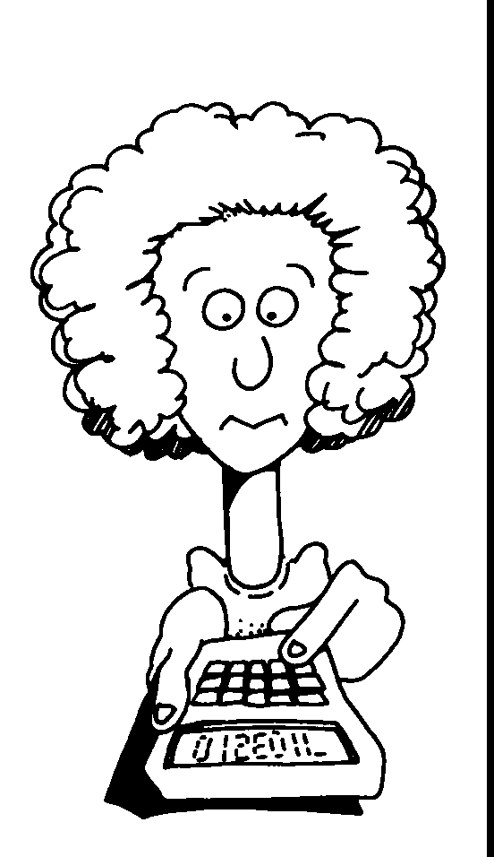

Investigate which types of visible light (or electromagnetic radiation?) can be used to run a solar powered calculator.

Extension: Use a solar powered calculator to investigate what materials can be used to shield different types of electromagnetic radiations from the Sun.

How numbers are shown in electronic machines: - trace electrical circuit. Sci or Skills in Persp?

Other possible tasks

Excellent tasks - Science in Perspective 2 - P 72 - all kinds - good for extension

Using electricity - Complete the diagram showing pathway of electricity and use etc Science Australia 1 p 168 - excellent for task!!!!!

Storing energy - Comprehension task, questions included - Science Works 2 P 183

Add up amount of energy have eaten for the day (and amount used?)

Write a story called - The year the Sun stopped shining

How does a solar cell work Sci Aust 1, P 178

Build a solar cell powered device

Investigate the best light to power a solar power battery

As well as producing heat, the burning of fuels can produce chemicals which can cause damage to the environment. Choose one way in which the burning of fuels damages the environment and prepare a poster/talk concerning this issue

Why use a lid? Activity - Living with Science and Technology 2 p 99

How vacuum flask works

Thermometers - how work - make models of

Solar power - is it all as good as it seems - pollution etc wise - present good and bad sides - from different aspects
imagine you are a farmer? coal miner???? Dynamic Science 2 p186

Exp - germinatating seeds - energy transfer that occurs.

Solar vs fossil fuel vs electricity car - which best?

Winds - sand colour, water - which heats up most - which lose heat quickest? - Science Moves 1 p135 - explain sea breezes

That Travelling Experience
Do exps to show - which energies move through what?
solid (different types - metals, non-metals, transparent, coloured), liquid, gas
- Light energy, magnetic energy, sound energy, electrical energy (static?) heat energy, - what can they move through? -- and how well - how quickly (for heat)??
- theory - how move through different methods of travel

Provide table for sts to summarise movement of energies - and through whatever - think of applications of this knowledge

Provide description of an eclipse occurring - ask to explain why it happens
- set up a working model which can be used to show what happens
- show/explain to class

Use light box to "prove" the law of reflection

Using mirrors, make a periscope to see above a wall

Design an experiment to see which materials are insulators and which materials are conductors of heat.
Describe uses of findings

Name useful batteries and explain what made of and how work

Apart from white, which coloured car is the best to keep cool in summer

OR Find a way of keeping X as cool as possible - or Y as hot as possible - explain methods used

Photosynthesis tasks - investigate effect of different coloured lights

Task - compreh - electromagnetic radiation - "Physics - Readings'

task - label energy sources Energy P43 - which are renewable etc - what use energy from these sources for
which due to solar E
Which sources do we use in Perth?

Or global problems

Hand in work, present talk, prepare information poster/leaflet

Why do we recycle aluminium cans?

Production of Al - explanation of why recycle cans - electrical energy costly - money wise and environmentally wise - do a calculation of costs????????

"To provide society with sources of energy, we destroy the environment." Choose an example to illustrate this quotation. Suggest an alternative, less destroying, way of producing the energy/solving this dilemma.

To provide society with sources of energy, we pollute the atmosphere. Choose an example to illustrate this statement.
Suggest an alternative, less destroying, way of producing the energy/solving this dilemma.

Wish to set up a factory which will use or generate a lot of energy (heat/noise) - what considerations need to make - how/where would you set up your factory?

Saving fossil fuels - cars
- houses, buildings

Energy sources of the future - investigate one of them - how change our life style, how would it work, problems, advantages

Electric cars - how work - advantages, disadvantages

Energy - Task 8. - Electrical Investigation

Choose one of the following questions concerning electrical energy. Carry out an experiment in an attempt to answer the question.

1. Can an electrical devise be made to test the steadiness of a person's hand? P 53 Science Quest 2.

other alternatives - Sci Work 8 - P 195

4. Which electrical appliance/devise in your house requires the most electrical energy to run it, and which uses the least? (Check with your teacher first before conducting this experiment)

5. Parallel and series circuits

6. Two-way switches

7. Fuses

task 2

Identify electrical appliances (or electrical energy converters) which are used in the home now and in the past
Recognise patterns in types of appliances used over time and their source of energy
Identify sources of energy used by appliances and people.
Recognise patterns in use of electrical energy in the home, over time.
Collect data from interviews or written material
Present data in a suitable table
Communicate findings in written form (neatly)
Organise time effectively (i.e. handed in on time)
Draw conclusions from data
Follow instructions - written and verbal

